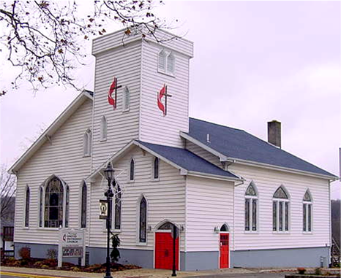
Newaygo United Methodist Church News
We are a caring and supportive community where all are welcome. We are God’s Dreamseekers who seek to make disciples in ways that show love, respect and service to our community.
Take Time
As I write this article I am also getting ready to head for Florida. My first vacation of the year was a wash out due to illness and subsequent sinus infection. But this time I sense that things will be different. Every once in a while we find ourselves in need of a way to get back in touch with ourselves and with God. The demands of a job, raising kids, keeping up with our social life, or the stress of not having enough to do, can weigh on us and begin to show in the ways we handle life. Jesus felt the same stresses, always being crowded and demands being made on him to heal and show signs of his abilities. But he knew enough to get away and even if he wasn’t successful (the crowds waiting for him on the other side of the lake) his intentions were there. He found his get a ways, sleeping in a boat, praying off by himself, and I imagine a whole host of other ways to be away from the pressures and stresses of his calling and who he was.
I have wondered how people can keep going without vacations, times of rest away from the normal. Prayer times are a good way to “get away.” It is then that we can let our guard down, let go of the stresses and just relax with God. We think we have to always have words to say, things to ask, situations to pray about. But prayer is much more than that. Prayer is a time to know that we are in the presence of a loving God that cares how we spend our time and how we consume our energy. Prayer is a time to let go, to relax from the strains of life. Prayer can get us into such a relaxed state that we literally fall asleep and catch a much needed nap. God knows what our needs are and when we create for ourselves a good environment to engage in contemplative prayer we are drawn closer to God in thought and presence and find a sense of wholeness that eludes us when stresses bombard us in our daily living. Even thinking about taking time just for ourselves can be stress invoking. We think we ought to be doing something. But the time we take to relax and connect with God, is an important activity for our sense of well-being. When life gets wearying there is nothing better in my mind than taking a trip to the beach, feeling the warmth of sunshine and the gentle rocking of the calm ocean and reconnecting with God. It is in that activity that I find the resource and energy to continue. I wonder if each of us has a place to enter into a “time away” and reconnect with God without the distractions of daily living. Let’s make sure we take the time.
Pastor Kathy

UMW Meeting Dates
All women are welcome at any of the following meeting. Join us when you are able.

Longcore Circle –We will meet on Tuesday, June 4, 2013 at 2pm. Meeting will be at Dorothy Sibley’s home.

UMW-Ladies Night Out – Tuesday, June 11, 2013 @ 6:30pm at NUMC We are studying “World Religions in 15 Minutes a Day” We read about a new religion each week and discuss. When questions arise, we look at other religions and discuss. You don’t need a book, just come join us for interesting conversation and good fellowship.

Mary Martha Circle – Tuesday, June 18, 2013 @ 9:30am. All women are welcome to join us we have a time of devotions and study. We meet at the church. Please join us.

Prayer Shawls

Knitters and people who can crochet wanted – knit at home or join us at Vera’s House on Wednesday’s at 8:30am. Some yarn has been donated for our shawls. See Dolores Cook, Jackie Pederson or Millie Stine.

The prayer shawls are given to persons who are struggling with something in their life. They provide a bit of comfort to let them know someone cares and is praying for them.

Please Remember these persons in your prayers.
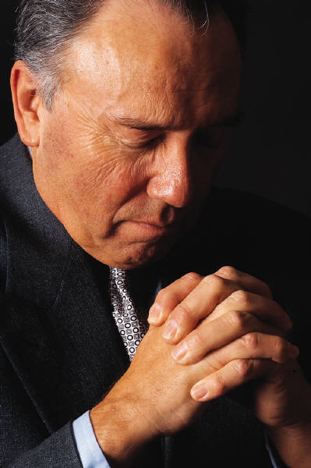

Arlene Beeler
Nancy Ferguson
June Wade
Jean Bumstead
William & Freda Corrigan
Gordon & Enid Schuiteman
Susanne Geerdink
George Suchy

To Heal a Friend
Think, o God, of our friend who is ill, whom we now commend to Your compassionate regard.
Comfort them upon their sickbed, and ease their suffering. We beg for deliverance, and submit that no healing is too hard for the Lord, if it be His will.
We therefore pray that You bless our friend with Your loving care, renew their strength, and heal what ails them in Your loving name.
Thank You, Lord.
Christian Education News

Sunday School is over for the year. We will begin Sunday school again on Sunday, September 8, 2013. Watch future newsletters and bulletins for more information.


VBS – Vacation Bible School
Vacation Bible School will be a farm theme this year and is going to be done in a little different format. It will be held two evenings during the week and then a celebration on Sunday morning with the whole congregation. The children learn how to build a friendship with Jesus and will be working on projects to help them be friends to those in their community and/or their environment.

We will be looking for helpers, items to use to decorate the church like a farm and also for snack donations and other items. Anne Henning is our VBS Chair and Patti Veneman is the Christian Education Chairperson so if you have any questions, items we can use to decorate or would like to
Thursday, August 1 – 6-8:30pm
Friday, August 2 – 6-8:30pm
Sunday, August 4 – 9:30-10:30am

volunteer to help in any way please contact one of them ASAP. Anne Henning 231-652-6191 or Patti Venneman 231-924-2118 or
venneman@localnet.com

Food Distribution to Families In Need
Newaygo County Mobile Food Pantry is scheduled at the following locations to distribute free food to individuals and families in need. Most food distributions take approximately one hour. Please do not arrive more than 30 minutes prior to the scheduled delivery time. Bring your won container to hold 50 lbs of food. You will check in upon arrival unless otherwise stated.

- Tuesday, May 28, 5pm, River Valley Community Church, NEWAYGO
- Wednesday, May 29, 10am, TrueNorth Community Services, FREMONT
- Saturday, June 1, 10am, Pine Grove Comm. Church, CROTON/HOWARD CITY
- Saturday, June 1, 1pm, Grant Wesleyan Church, GRANT, Call to Pre-Register 231-834-7222
- Monday, June 3, 5pm, Fremont United Methodist Church, FREMONT
- Friday, June 7, 10am, St. Joseph Catholic Church, WHITE CLOUD, Sponsored by Local Area Churches
- Saturday, June 8, 9:30am, First Christian Reformed Church, FREMONT

A complete list of food trucks is posted on the bulletin board at the church. Call the church office if you have any questions at 652-6581.

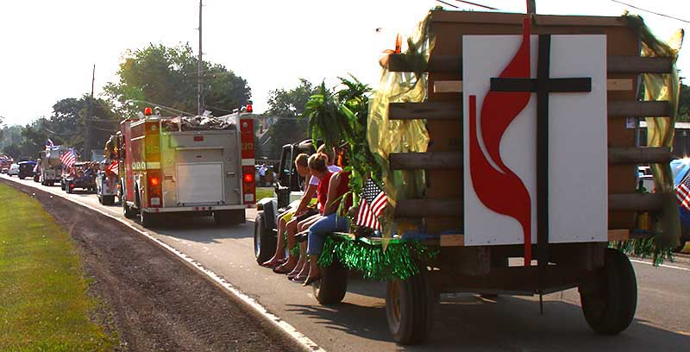
Church Float For Parades

Goal: Make our church more visible in the community

One way to do this is to take part in a parade. This provides publicity and visibility. It is a ministry that can raise the visibility of the church and the spirits of the people in the church.

If you would like to be involved in creating a float for Newaygo United Methodist Church to use in community parades, please contact Lynne Cutler at 231-834-5727 or Lynne.cutler17@gmail.com
June Birthdays
6/8 Candace Kroll
6/9 David Brooks
6/11 Dorothy Sibley
6/18 Mary Jane Cook
6/19 Gladys Kroll
6/20 Jona Bumstead
6/29 Olivia Robeck


2013 Mission Giving

Dresses for Haiti $ 740.00
Habitat for Humanity 117.50
Haiti School Kits 326.47
Human Relations 78.00
Kids Hope-local 98.22
LOVE - food pantry 206.45
Native American 70.00
One Great Hour of Sharing 74.25
______
$ 1710.89
“Give and it will be given to you. … For with the measure you use, it will be measured to you.”
Luke 6:38

Upcoming Mission Concerns

April 9 – Love Food Pantry
April 23 – Camp Sunday
Camp Sunday
This month we will be collecting our noisy offering for the UMC camps. The money donated will help refurbish buildings, and grounds and purchase new equipment that is necessary to provide our children with an enjoyable camping experience where they will have the opportunity to learn and experience God’s love first hand. Thank you for supporting our camps.

June Anniversaries

6/4 Jon & Sherry Graham
6/9 Stanley & Janet Fisher
6/12 Calvin & Barbara Deitz
6/15 Norm & Alicia Pedalty
6/16 William & Freda Corrigan
6/21 Jeff & Julie Berwald
6/26 Steve & Brenda Bonter
Happy Anniversary


Worship Helpers for June

June 2
Liturgist: Ron Pardonnet
Acolyte: Elizabeth Brooks
Inside Ushers: Vern & Carolyn Boose
Outside Ushers: Ann Henning & Jean Reynhout
Projector: Deb Prins
Sound: Deb Prins

June 9
Liturgist: Nancy Clark
Acolyte: Elijah Brooks
Inside Ushers: Ron & Kay Pardonnet
Outside Ushers: Joan Faulkner & Dolores Cook
Projector: Taylor Prins
Sound: Need Volunteer

June 16
Liturgist: Kay Pardonnet
Acolyte: Colby Brooks
Inside Ushers: Millie Stine & Ruth Merritt
Outside Ushers: LeeAnn Hesse & Jane Bode Fowler
Projector: Elijah Brooks
Sound: Deb Prins
EMMA L. GRAHAM SCHOLARSHIP FUND
Jon and Sherry Graham have started a scholarship in memory of their daughter, Emma Graham at Fremont Area Community Foundation. Fremont Area Community Foundation will match donations made to the Emma L. Graham Scholarship Fund up to $500 per household until May of 2013. Donations can be sent directly to the Fremont Area Community Foundation at P.O. Box B, Fremont, MI, 49412.

Matching funds from Fremont Area Community Foundation end soon so please make your donations by the end of May.



June 23
Liturgist: Carline Knoll
Acolyte: Taylor Prins
Inside Ushers: Dianna Weaver & Jen Larsen
Outside Ushers: Carline Knoll & Harriet Kiper
Projector: Taylor Prins
Sound: Deb Prins

June 30
Liturgist: Joe Groff
Acolyte: Elizabeth Brooks
Inside Ushers: Joan Faulkner & Dolores Cook
Outside Ushers: Dan & Ardie Coby
Projector: Taylor Prins
Sound: Deb Prins

If you are unable to serve on the day you are scheduled, please find someone to fill in for you or call the church office as soon as possible.

Ride for Haiti
For Christ’s Sake,
Keep Pedaling
www.haitiride.org

June 12-15, 2013
Grand Haven MI
To make donations please go to www.haitiride.org or contact Roger Cox – ride Coordinator at rgcox2@gmail.com or Rob Nystrom at rnr@comcast.net

Projects we will be sponsoring in 2013:
Haitian Artisans for Peace International (HAPI)
United Methodist Volunteers in Mission
(Haiti UMVIM)


Community Events

Community Picnic & Sudanese Peace Concert
June 15th, 2013

The Newaygo Area Ministerial Association and Newaygo County People for Peace are honored to sponsor a family friendly, community-wide event that promotes unity and compassion and helps “sow peace” around the world.
5:30pm - Free hotdog supper provided by Newaygo Ministerial Association
6:30pm – Concert in the park (rain location Family of God Community Church, 90 Quarterline Road, 1 block ease of Brooks Park.)
We need volunteers to provide 10 doz cookies and 2 to help set up and clean up.

Living On – Grief Support Group
Starts 6/11/13
Every 2nd Tuesday of each month at 1pm-2:30pm at 33 W. Main Street, Fremont
For questions call Tangela:231-769-7371
Sponsored by Hospice of Michigan

2013 Senior and Caregiver Expo:
Thursday, June 20
9am-1pm
The Senior & Caregiver Expo brings community resources to one location where seniors and their caregivers can get information from agencies and businesses; attend classes of interest to them; see demonstrations of products or services. This is a free event with breakfast and lunch provided.
Church Staff
Pastor: Kathy Groff
Pastor Kathy is in the church office on Monday and Wednesday Mornings and other times by appointment.
Phone: 231-652-6581
Email: kthlngrff@gmail.com

Administrative: Deb Prins
Deb is in the office Monday –Thursday from 9am to 2:15pm
Phone: 231-652-6581
Email: debprins@sbcglobal.net

Kids Hope Director: LeeAnn Hesse
Phone: 231-652-7435
Email: l.hesse@sbcglobal.net

Organist: Lois VanDyke
Phone: 231-924-2329
Email: loisvandyke@hotmail.com

Choir Director: Cathy Badge
Phone: 231-652-1478
Email: bbadge@riverview.net

Custodian: Karen Winchel
Phone: 231-689-0677
Email: sahoka_farms@yahoo.com

Please feel free to contact any of the church staff if you have any questions or concerns.


Newaygo County Kids Day

June 22nd
Noon -4pm

We will be hosting the ladder ball game so I will need at least 8 volunteers so that we have 4 volunteers per 2 hour shift.

Please contact Deb Prins @ 231-652-6581.


Treasurers Report
Thank you for being such a giving and generous church. Each month we are able to meet the needs of the church and we are on track to pay 100% of our Ministry Shares for 2013. THANKS BE TO GOD!

Contributions through May 25, 2013 - $ 7,589.00
Expenses through May 25, 2013 - $ 7,129.00
Total Overage $ 460.00
Keep in mind that you are receiving this information with one Sunday of Giving left to receive and there are still salaries of $2,146 at the end of the month. If you have any questions or would like to see a more detailed treasurer’s report please call Deb Prins at 231-652-6581 or see the copy of the reports posted on bulletin board in the church office.
Please prayerfully consider how you will continue to support the ministries of Newaygo United Methodist Church with your prayers, time, talents and treasures.

West Michigan Annual Conference of the United Methodist Church

May 29-June 1, 2013
At Calvin College

Focus will be “Inspire”

Drive In Day will be Saturday, June 1, 2013

Contact Deb Prins by May 31st to register for drive in day!

May 2, 2013
Dear Prayer Warriors,
This is to thank you all for praying for my 31yr old grandson, Mathew Engle. His big blood clot isn’t entirely gone so he is still on blood thinners and blood draws.

I really appreciate your prayers for him. God is looking out for his health through the praying of many.

I thank you again and hope when you think of him once in a while you will remember him in your prayer time.

Thank you very much and I thank my dear friend always for putting Matt on your prayer list.
Love In Christ,
Iola DeJohn
Men’s Club

I missed a couple of breakfast club meetings this month so I will not be able to fill you in on the high level talks that were conducted. Now might be a good time to appoint an alternate recording secretary to resolve this problem before it gets to be serious. At any rate, I am home, able to sit up and take nourishment. More Later.
Don Pederson


There is still time to register for camp!
Scholarships are available through the church. Contact Deb Prins for more information.
Why is camp so important?
Kids need camp! Today, like never before, many teens and pre-teens are under tremendous stress, self-doubt and peer pressure. Even kids who have a strong support structure face obstacles. Camp provides opportunities for students to pull away and get a breather - to catch a vision for the bigger picture of their lives. Camp is a positive life changing experience! That's why kids keep returning year after year to West Michigan Conference camps.

Church Picnic
Sunday, June 23, 2013
At the Henning’s Home
438 Emerald Lake Drive
Following Worship
EVERYONE is welcome!

(Bring a dish to pass and your own table service. Burgers and hot dogs will be provided)

MARK YOUR CALENDARS TODAY!



Giggles & Grins

The good Lord didn’t create anything without a purpose but bedbugs and mosquitoes come pretty close.

Some people are kind, polite, and sweet-spirited until you try to sit in their pews.

People are funny they want the front of the bus, the middle of the road and the back of the church.


Newaygo United Methodist Church Activities
Mary Martha Circle Rummage & Plant Sale

May 23rd & 24th
9am-4pm

Mark your calendars today!!!!
Start cleaning out your closets and bring your donations for the rummage sale in by Wednesday, May 22nd. Please bring your plants and garden items in by Thursday, May 23. You may leave your donations on the table in the basement marked “Rummage Sale Donations”. Thank you in advance for your support.

If you have any questions or would like more information please contact Carline Knoll at 231-652-1147
June 2013

Sunday | Monday | Tuesday | Wednesday | Thursday | Friday | Saturday
 |  |  |  |  |  | 1
2  9:30am – Worship | 3  9am -12pm Pastor Kathy’s Office Hours  1:00pm – Wired Word Bible Study | 4  2:00pm – Longcore Circle | 5  8:30am – Men’s Group @ City Limits  9am -12pm Pastor Kathy’s Office Hours  7pm - Choir | 6  Pastor Kathy’s Day Off | 7 | 8
9  9:30am – Worship  LOVE INC OFFERING | 10  9am -12pm Pastor Kathy’s Office Hours  1:00pm – Wired Word Bible Study  6:30pm – Christian Education Meeting | 11  6:30pm – Ladies Night Out | 12  8:30am – Men’s Group @ City Limits  9am -12pm Pastor Kathy’s Office Hours  7pm - Choir | 13 | 14 | 15
16 FATHERS DAY  9:30am – Worship  CHILDREN SING | 17  9am -12pm Pastor Kathy’s Office Hours  1:00pm – Wired Word Bible Study | 18  9:30am – Mary Martha Circle  6:30pm – Finance  7:00pm – Church Council | 19  8:30am – Men’s Group @ City Limits  9am -12pm Pastor Kathy’s Office Hours  7pm - Choir | 20 | 21 | 22  8am-11am – 4th Saturday Pancake Breakfast  12pm-4pm – Newaygo County Kids Day
23  9:30am – Worship  NOISY OFFERING  11:00am – Church Picnic @ Hennings | 24  9am -12pm Pastor Kathy’s Office Hours | 25 | 26  9am -12pm Pastor Kathy’s Office Hours | 27 | 28 | 29
30
9:30am – Worship

If you have questions, concerns or an activity to add to the calendar, please call the church office at
231-652-6581 or email Deb Prins at debprins@sbcglobal.net.

June 2013
Each month in 2013 there will be a calendar available with bible readings to guide you chronologically through the bible in one year. If you have any questions please feel free to call the church office at 652-6581
Sunday | Monday | Tuesday | Wednesday | Thursday | Friday | Saturday
1 Proverbs
17:1-19:29

2  Proverbs 20:1-22:16 | 3  Proverbs 22:17-24:34 | 4  Song of Songs 1:1-8:14 | 5  1 Kings  11:1-43  2 Chronicles 9:29-31  Ecclesiastes 1:1-11 | 6  Ecclesiastes  1:12-6:2 | 7  Ecclesiastes  7:1-11:6 | 8  Ecclesiastes  7:1:7-12:14  1 Kings 12:1-20  2 Chronicles  10:1-19  1 Kings12:21-24  2 chronicles  11:1-4  1 Kings 12:25-33  2 Chronicles 11:5-17
9  1 Kings 13:1-14:24  2 Chronicles 12:13-14  2 Chronicles 11:18-23  2 Chronicles 12:1-12  1 Kings 14:25-28  2 Chronicles 12:13-16  1 Kings 14:29-15:5  2 Chronicles 13:1-22  1 Kings 15:6-8  2 Chronicles 14:1-8  1 Kings 15:9-15  1 Kings 14:19-20  1 Kings 15:25-34  2 Chronicles 14:9-15:19 | 10  1 Kings 15:16-22  2 Chronicles  16:1-10  1 Kings 16:1-34  1 Kings 15:23-24  2 Chronicles  16:11-17:19  1 Kings 17:1-7 | 11  1 Kings  17:8-20:22 | 12  1 Kings  20:23-22:9  2 Chronicles 18:1-8 | 13  1 Kings 22:10-28  2 Chronicles 18:9-27  1 Kings 22:29-35  2 Chronicles  18:28-34  1 Kings  22:36-40,51-53  2 Chronicles  19:1-20:30 | 14  2 Kings 1:1-18  2 Kings 3:1-27  1 Kings 22:41-49  2 Chronicles 20:31-37  1 Kings 22:50  2 Chronicles  21:1-4  2 Kings 8:16-22  2 Chronicles  21:5-7 | 15  2 Kings 2:1-25  2 Kings 4:1-44
16  Psal2 Kings 5:1-8:15 | 17  2 Chronicles  21:8-20  2 Kings 8:23-29  2 Chronicles 22:1-7  2 Kings 9:1-10:17  2 Chronicles 22:8-9  2 Kings10:18-31 | 18  2 Kings 11:1-3  2 Chronicles 2:10-12  2 Kings 11:4-12  2 Chronicles 23:1-11  2 Kings 11:13-16  2 Chronicles 3:12-15  2 Kings 11:17-21  2 Chronicles 23:16-21  2 Kings 12:1-16  2 Chronicles 24:1-22  2 Kings10:32-36 | 19  2 Kings 13:1-11  2 Kings 12:17-21  2 Chronicles 24:23-27  2 Kings 13:14-25 | 20  2 Kings 14:1-14  2 Chronicles  25:1-24  2 Kings 13:12-13  2 Kings  14:15-16, 23-27  2 Chronicles  25:25-28  2 Kings 14:17-22  2 Kings 15:1-5  2 Chronicles  26:1-21  Jonah 1:1-4:11 | 21  Amos 1:1-6:14 | 22  Amos 7:1-9:15  2 Kings 14:28-29  2 Kings15:8-29, 6-7  2 Chronicles 26:22-23  Isaiah 6:1-13
23  2 Kings 15:32-38  2 Chronicles 27:1-9  Micah 1:1-16  2 Kings 16:1-9  2 Chronicles 28:1-15  Isaiah 7:1-25 | 24  Isaiah 8:1-11:16 | 25  Isaiah 12:1-6  Isaiah 17:1-14  2 Chronicles  28:16-21  2 Kings 16:10-18  2 Chronicles  28:22-25  2 Kings 18:1-8  2 Chronicles 29:1-2  2 Kings 15:30-31  2 Kings 17:1-4  Hosea 1:1-2:13 | 26  Hosea  2:14-8:14 | 27  Hosea 9:1-14:9 | 28  Isaiah 28:1-29  2 Kings 17:5  2 Kings  18:9-12  2 Kings  17:6-41  Isaiah 1:1-20 | 29  Isaiah  1:21-5:30
30
2 Kings 16:19-20
2 Chronicles 28:26-27
Isaiah 13:1-16:14


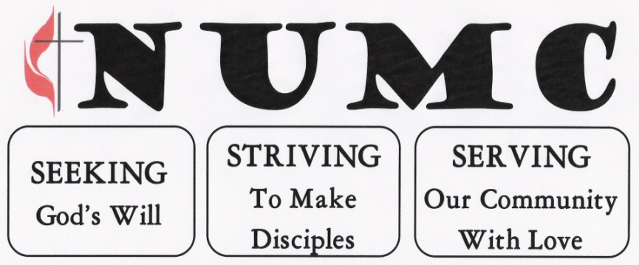
Newaygo United Methodist Church Newsletter

Deadline for articles is 4:00PM on the 20th day of each month in the church office.

The Editor reserves the right to edit for content and space.
Newaygo United Methodist Church
Newaygo United Methodist Church
101 State Street
P.O. Box 366
Newaygo, MI 49337
June 2013 Newsletter
Join us for worship on Sunday morning at 9:30 am with fellowship following.

