

### Inside This Issue

Pastors Ponderings 1

Rummage Sale 2

Fellowship Opportunities 2

Treasurers Report 3

Pastors Resource 3

Christian Education 4

Kids Hope USA 4

Mission Minutes 5

Worship Helpers 6

Calendar of Events 7

Mark your calendars – Upcoming Picnic’s

**June 28th** – All Church Picnic @ the Hennings

To celebrate Sunday School

**July 14th** – All Church Cookout at the Church

(sponsored by UMW)

***Watch newsletters and bulletins for more information!***

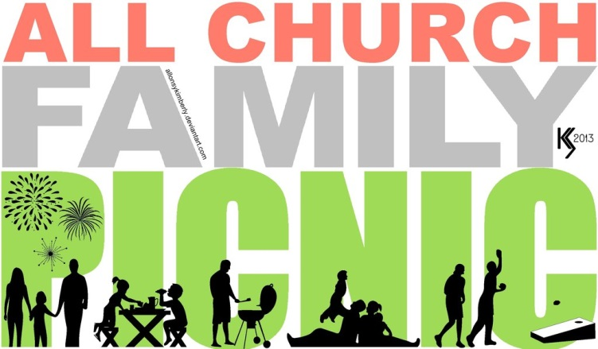

**Always Looking for Stuff**

One of the things I dislike most in life is looking for lost “stuff”. When I begin the search, I am feeling ok about it, but as the search goes on with no results I find myself becoming more and more irritated. Then I begin to lament that I am always looking for things and wondering why I can’t be more organized. But the search goes on with more and more frustration as I come up empty. Most likely all that frustration is for something I don’t truly need in the first place. I always seem to survive when I don’t find what I am looking for.

But, there are truly important things in life that we could be looking for, namely food for our spirits. Sometimes we are not quite sure where to look for what will fill our souls and make us whole. We are on the right path, however, when we ready and study scripture, pray, attend church, and fellowship with one another. We look in all the right places for that which will feed our souls. But are we aware that God is also involved in that search? God is there inspiring, guiding, motivating, hinting, calling, inviting and whatever else God does to get us to pay attention and learn.

Relationship with God is always a two way street. We benefit from that relationship when we pay attention to God and how God speaks to us. Our “sense” of God grows as we interact with God, as we pray and recognize where God is working in our lives. Praying, reading inspirational materials, and other ways of “talking” about God will help us develop our “God sense”. It’s not a one time, aha, I’ve found it thing! It takes time to develop that sense of our connection with our Creator. In fact we don’t know the fullness of God until that time comes when we let go of this life and take His hand into new life. But we do get some very powerful glimpses of what that relationship can be like, glimpses of “heaven”.

The search for that which fills us, namely God, is always a good search. A few times we may come up empty, but most of the time we find little pieces that add to our understanding. Always there is more to learn about God. Happy searching!

God’s Dream Seekers News

# Pastors Ponderings

By Pastor Kathleen Groff

###### Newaygo United Methodist Church, P.O. Box 366, Newaygo, MI 49337; email:umcnew@newaygoumc.com; phone: 231-652-6581; website: www.newaygoumc.com

May 2015

Volume 2, Issue 5

**United Methodist Women’s Meetings**

Each meeting is open to all women. Please join us for which ever one you are able to. You are always welcome.

* **Longcore Circle –**May 5th , at 2pm at Dorothy Sibley’s Home. All are welcome.
* **Ladies Night Out** –Tuesday, May 12th @ 6:30pm – We will have a business meeting and then study a very interesting “Women of the Bible” We will be discussing the Ladies Tea which has been postponed until June and the All Church picnic which will be held in July.
* **Mary Martha Circle –** Tuesday, May 19th at 10:30am. ***Meet at church to carpool to Loda Lake bring picnic finger foods.*** All women are welcome.





Men, come join us on **Wednesdays at 8:30am at the City Limits Restaurant**

(next to McDonalds).

"We welcomed our snow bird Duane back with a little bit of snow!!    He said he couldn't see it. He had tears in his eyes maybe because he left 80 degree weather and came back to 30 degree weather!!  After four years of attending men's group, we finally had one subject we all agreed on!  No matter how much gravy, salt and pepper, ketchup, or spices, we all agree sushi still should only be eaten by cats. I want to thank Vern for the flies he made for me.  I really appreciate them.  He did divulge a secret however, that is his quality control.  It seems if he wants to make sure the flies look real, he puts one on the kitchen table and if Carolyn gets the fly swatter and goes after it, it was a success!  Way to go Vern, keep it in the family.  So men, you learn a lot at the Wednesday group at the City Limits, So stop on in for a breakfast and a laugh."

Joe Groff



& Plant Sale

Memorial Day Weekend

Friday, May 22nd

from 9am – 6pm

Saturday, May 23rd

from 8am – noon

*SPRING CLEANING* – it is time to do your spring cleaning and planting. Please save your household items, furniture, tools, **plants** etc. and donate them to the Church Rummage Sale. NO CLOTHING! PLEASE DONATE YOUR CLOTHING TO LOVE INC.

*This sale is sponsored by the Mary Martha Circle and all monies raised are given to missions that affect women and children, both locally and globally.*

HELP!!!!!!!!!!!!!!!!!!!!!!

* We will need help setting up the tables and items on Thursday, May 21st. We need people who can carry heavy items to help. The sale will be set up upstairs this year.
* People to keep the sale open until 6pm on Friday and to have the sale open on Saturday, 8am-noon.
* People to help clean up and take leftover items to be donated.

***There is a sign up sheet in the coffee area. Please mark your calendars today and plan to volunteer.***

**

**Pastor’s Resource List**

We all love our Pastor and would love to keep her as long as possible. One way to do this is to give her all the help we can. We all know that we are an important part of the ministry of the church of Love. The Pastor cannot be expected to do it all. Here is one way we can help: We can become part of a resource team to help our Pastor minister to those in need.

This could include; driving persons to Dr., pick up medicine etc. The church has at times received emergency requests for transportation help. Rather than have the Pastor drop everything and run to drive, we could volunteer to do it.

Another way to help would be to make yourself available to visit those in need of a visit from the church in place of the pastor.

A third possibility would be to take in a food dish to help a family in an emergency.

John Wesley’s philosophy is “DO GOOD”. Here is our chance to do good. We can become part of our **Pastor’s Resource List**. Look for volunteer sign-up sheets at coffee hour on Sunday Mornings.

*Ron Pardonnet*

SIGN UP SHEET IN COFFEE

AREA AT CHURCH!

If you need help with something, please give the church office a call.

We don’t know you need help unless you tell us. Please call

231-652-6581 if you are in need and we will try to find those

within the church that can help.



Dan & Edna Schilling

Nancy Ferguson

Jean Bumstead

Wayne Bumstead

Bill & Freda Corrigan

June Wade

Al Winchel

Chuck Suess

Nepal – Earth Quake

Peace in the World

*If you have a prayer request or person you would like added to the monthly prayer list, please let Deb Prins know and we will add them to the newsletter each month.*

**Psalm 147:3**  
*He heals the brokenhearted and binds up their wounds.*

*Treasurer’s Report*

Please prayerfully consider how you can help support the ministries of Newaygo United Methodist Church in 2015.

Contributions through

April 30th , 2015 - *$ 9,895.67*

Expenses through

April 30th , 2015 - $9,295.87

**Total 599.80**

$8,585.00 was removed from the MI Area Loan Fund Account (Building Fund) and $1,395 from Memorial Funds to pay for new sewer lines at the church. Quotes for new flooring in the basement are currently being sought.

If you have any questions or would like to see a more detailed report please call Deb Prins at 231-652-6581 or see the copy of the reports posted on bulletin board in the church office.





Bills Shop N Save Receipts

Please save your Bill’s Shop N Save receipts and turn them in to Kay Pardonnet. She will then turn them in and the church will receive $25.00 each time she is able to turn in receipts.





**Sunday School**

For all ages every Sunday at 11am

Sunday School for 2014-2015 school year ends on Sunday, May 17th.

***Christian Education Meeting***

***Monday, May 18th @ 6:30pm @ Newaygo Congregational United Church of Christ***

Vacation Bible School Planning

Vacation Bible School – Out Back Rock

Mark your Calendars

July 9 @ 6pm-8:30pm

July 10 @ 6pm-8:30pm

July 12 @ 9:30am

Watch future bulletins and newsletters for more information.



Kids Hope USA

End of Year Party

Wednesday, May 20th

2pm-3pm

@ Velma Matsen Upper Elementary

Cafeteria



**Position Available**

Newaygo United Methodist Church is looking for an enthusiastic person to become our Kids Hope USA Director. The person should be:

* interested in working with children
* excellent at communication with mentors, prayer partners, church staff, school staff and parents.
* attend church regularly in order to have face to face contact with our congregation
* willing to attend a 2 day training
* willing to recruit and train new mentors
* an hourly rate of $10, with a yearly stipend limit of $1,200

If you are interested in the position or have questions, please see Ron Pardonnet for more information on how to apply.



2015 Pancake

Breakfast

Date Pending Flooring replacement in basement.

Saturday, May 23rd

Serving 8am-11am

All you can eat pancakes, sausage, scrambled eggs, biscuits & gravy and American fries, drink & fruit.

Mark your calendars today! Invite your friends and neighbors!

**If you can help please see Jean Reynhout ASAP!**

*TOGETHER, WE SPREAD THE GOSPEL OF PEACE AND ENCOURAGE COOPERATION LOCALLY, IN THE UNITED STATES AND GLOBALLY*.

Noisy Offering Peace With Justice Sunday is May 31st, 2015

In Arizona border towns, communities facing social challenges are dramatically divided. In Liberian villages, citizens’ human rights are being violated. In local U.S. communities, women and girls are being bought and sold against their will.

Moved by Christ’s love to pursue reconciliation and peace, honoring the dignity of every individual made in God’s image, The United Methodist Church is unwilling to turn a blind eye to injustice.

Although you, and even our congregation, lack the resources alone to effect change in a broken world, our giving is vital for the UMC to continue its global ministries of reconciliation. Because of the Peace with Justice Sunday offering, the people of The United Methodist Church are able to make a difference together by sowing seeds—and yielding fruit!—of peace.

When we give on Peace with Justice Sunday, our gift makes possible our critical kingdom work in the world. Because we give:

**Methodists spearhead a peace ministry uniting Arizona border communities**

**United Methodists in Liberia are being equipped to implement the denomination’s Social Principles to address social-justice issue**

**Pennsylvania students are educating their community about sex-trafficking at home and abroad**

These initiatives, and hundreds of others, are possible because we give.

***Our Giving Makes Possible the Proclamation of Christ’s Peace***

In Jesus’ inaugural address, standing in his home synagogue in Nazareth, he detailed his game plan,

***“The Spirit of the Lord is on me, because he has anointed me to proclaim good news to the poor. He has sent me to proclaim freedom for the prisoners and recovery of sight for the blind, to set the oppressed free, to proclaim the year of the Lord’s favor.” (Luke 4:18-19)***

**Thank you.**

**The Missions Committee**

# Mission Minutes



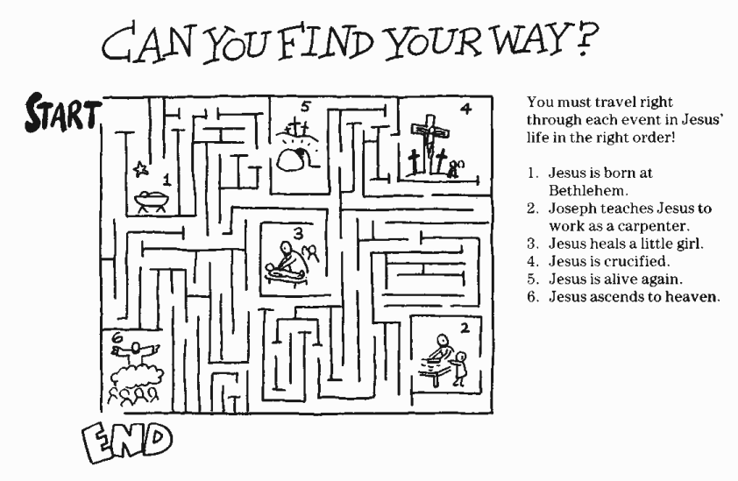



**May 3**  
**Liturgist:** Kay Pardonnet

**May 24**   
**Liturgist:**  Ron Pardonnet

**Acolyte:**  Gabriella Brooks  
**Inside Ushers:** Jean Reynhout & Ruth Merritt  
**Outside Ushers:** Janet Fisher & Anne Henning

**Projector:** Jen Larsen

**Sound:** Need Volunteer

**May 31**   
**Liturgist:**  Nancy Clark

**Acolyte:**  Blake Larsen  
**Inside Ushers:** Duane & Marilyn Witter  
**Outside Ushers:** Janet Fisher & Anne Henning

**Projector:** Elizabeth Brooks

**Sound:** Deb Prins

If you would like to help with worship services on Sunday morning, please see Deb Prins and we will add you to the list of worship helpers.



**Acolyte:**  Morgan Pope  
**Inside Ushers:** Jen Larsen & Jane Bode Fowler  
**Outside Ushers:** Dorothy Bessemer & Dolores Cook

**Projector:** Deb Prins

**Sound:** Taylor Prins

**May 10**  
**Liturgist:**  Marilyn Witter

**Acolyte:**  Gabriella  
**Inside Ushers:** Joan Faulkner & Millie Stine   
**Outside Ushers**: Vern & Carolyn Boose

**Projector:** Need Volunteer

**Sound:** Need Volunteer

**May 17**  
**Liturgist:**  Carline Knoll

**Acolyte:**  Elizabeth Brooks  
**Inside Ushers:** Jen Larsen & Dianna Weaver

**Outside Ushers:** Carline Knoll & Deb Prins

**Projector:** Taylor Prins

**Sound:** Deb Prins

**May Birthday’s**

5/2 Saria Brooks

5/4 Chris Bainbridge

5/5 Matthew Brooks

5/9 Colleen Hood

5/11 Blake Larsen

5/1 Cathy Badge

5/15 Lynne Cutler

5/15 Kenneth Cain

5/18 Brenda Huckins Bonter

5/20 Paul Wright

5/25 Keith Johnson

5/28 Dawn Carr

5/29 Sue Osborn

5/31 Al Winchel

5/31 Jen Larsen



**May Anniversaries**

5/11 Tim & Deb Prins

5/19 Dave & Connie VanderHyde



|  |  |  |  |  |  |  |
| --- | --- | --- | --- | --- | --- | --- |
|  |  |  |  |  |  |  |
| **Sunday** | **Monday** | **Tuesday** | **Wednesday** | **Thursday** | **Friday** | **Saturday** |
|  |  |  |  |  | 1 | 2 |
| **3**  9:30am – Worship  11am – Sunday School for all ages | 4  9am -12pm Pastor Kathy’s Office Hours  1:00pm – Wired Word Bible Study | 5  2:00pm – Longcore Circle | 6  8:30am – Men’s Group @ City Limits  9am -12pm Pastor Kathy’s Office Hours  7pm – Choir Practice | 7  Pastor Kathy’s Day Off | 8 | 9 |
| **10**  9:30am – Worship  11am – Sunday School for all ages | 11  9am -12pm Pastor Kathy’s Office Hours  1:00pm – Wired Word Bible Study | 12  6:30 –Ladies Night Out – UMW MEETING | 13  8:30am – Men’s Group @ City Limits  9am -12pm Pastor Kathy’s Office Hours  7pm – Choir Practice | 14  Pastor Kathy’s Day Off | 15 | 16  12pm - UMW provide luncheon for Patti Meengs Memorial |
| **17**  9:30am – Worship 11am – Sunday School for all ages **Last Day of Sunday School** | 18  9am -12pm Pastor Kathy’s Office Hours  1:00pm – Wired Word Bible Study  6:30pm – Christian Education Mtg. @ UCC | 19  10:30am – Mary Martha Circle – Loda Lake Outing  6:30pm – Finance & Church Council | 20  8:30am – Men’s Group @ City Limits  9am -12pm Pastor Kathy’s Office Hours  7pm – Choir Practice | 21  Pastor Kathy’s Day Off  9:00am – Set up for Rummage Sale | 22  9am – 6pm - Rummage Sale | 23  8am – 11am - 4th Saturday Pancake Breakfast  8am – 12pm – Rummage Sale |
| **24**  9:30am – Worship | **25**  Church Office Closed – Memorial Day | **26** | 27  8:30am – Men’s Group @ City Limits  9am -12pm Pastor Kathy’s Office Hours  7pm – Choir Practice | 28  Pastor Kathy’s Day Off | 29 | 30 |
| **31 NOISY OFFERING**  9:30am – Worship |  |  |  |  |  |  |

Newaygo United Methodist Church Activities –2015



*We’re on the Web!*

*Visit us at:*

[www.newaygoumc.com](http://www.newaygoumc.com)

or check us out on facebook: Newaygo United Methodist Church

We are God’s Dream Seekers who seek to make disciples of Jesus Christ in ways that show love, respect and service to our community.

Mission

Newaygo United Methodist Church

P.O. Box 366

Newaygo, MI 49337

Join us on Sunday Mornings for Worship at 9:30am with fellowship following. Sunday School for all ages at 11am.

If you have any questions or would like more information regarding worship services and activities at Newaygo United Methodist Church please feel free to call the church office Monday-Thursday 9am-1pm.

##### Newaygo United Methodist Church

P.O. Box 366

Newaygo, MI 49337

##### Phone:

231-652-6581

##### Fax:

231-652-6601

##### E-Mail:

umcnew@newaygoumc.com